Day 9 - 11th June 2025

Exceptions:

Types Exceptions:

Task 01:
What do you understand by exceptions?
An exception is an unexpected event during program execution that disrupts the normal flow of instructions, requiring special handling to prevent crashes. It ensures errors are managed efficiently for smooth operation. For example, If a program tries to divide a number by zero, an exception occurs, disrupting execution unless handled properly.

Task 2:

What are the categories of Exceptions do we have in Java? What are they?
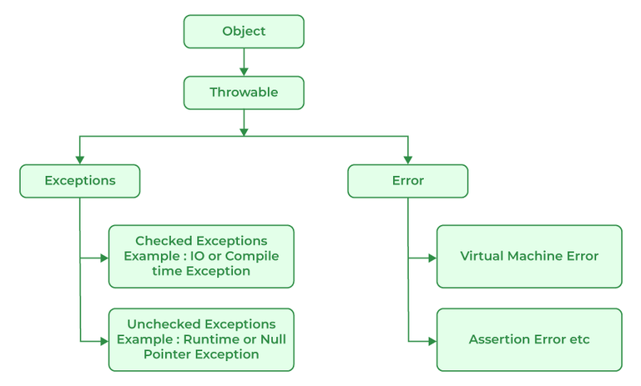

Plz refer the above image .. for more details.

- Checked Exceptions.
Example: IOException, SQLException.
- Unchecked Exceptions (Runtime Exceptions)
Example: NullPointerException, ArrayIndexOutOfBoundsException, ArithmeticException.
- Errors
Example: OutOfMemoryError, StackOverflowError.

Task 3:

Can you try the below code snippet and let me know which kind of exception is this

// Java program to demonstrates handling
// the exception using try-catch block
import java.io.*;

class Geeks {
public static void main(String[] args)
{
int n = 10;
int m = 0;

try {

// Code that may throw an exception
int ans = n / m;
System.out.println("Answer: " + ans);
}
catch (ArithmeticException e) {

// Handling the exception
System.out.println(
"Error: Division by zero is not allowed!");
}
finally {
System.out.println(
"Program continues after handling the exception.");
}
}
}
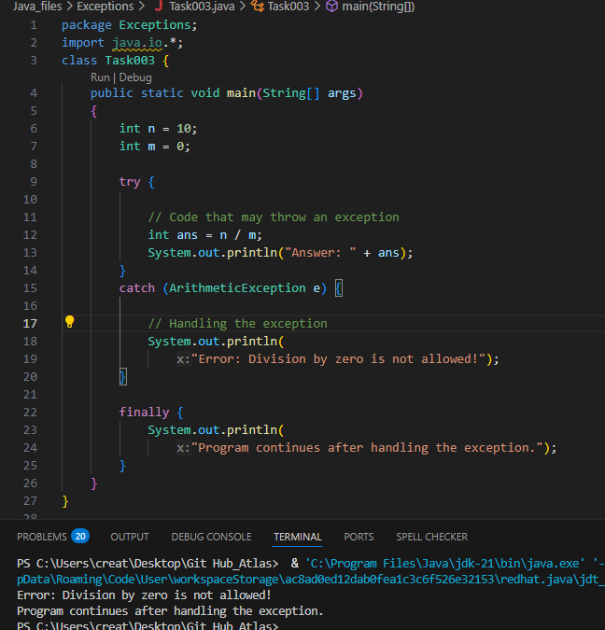
Task 04
List of checked and unchecked exceptions.
Checked Exceptions (Must be handled or declared with throws)
- IOException – File handling errors
- SQLException – Database connection issues
- FileNotFoundException – Missing files during read operations
- ClassNotFoundException – When a class is not found at runtime
- InterruptedException – Issues with thread execution
- ParseException – Errors while parsing date or formatted data
- CloneNotSupportedException – If cloning is not supported for an object
Unchecked Exceptions (Occur at runtime without explicit handling)
- NullPointerException – Accessing methods or properties on a null object
- ArrayIndexOutOfBoundsException – Accessing an invalid array index
- ArithmeticException – Division by zero or invalid mathematical operations
- NumberFormatException – Converting invalid strings to numbers
- IllegalArgumentException – Passing invalid arguments to a method
- ClassCastException – Incorrect type conversion between objects
- IllegalStateException – When the application is in an incorrect state
Task 5:

Try with Multiple catch blocks …. Execute the below code snippet n display the out .. along with reason..

public class ExcepTest {

public static void main(String args[]) {
try {
int a[] = new int[2];
int b = 0;
int c = 1/b;
System.out.println("Access element three :" + a[3]);
}
catch (ArrayIndexOutOfBoundsException e) {
System.out.println("ArrayIndexOutOfBoundsException thrown :" + e);
}catch (Exception e) {
System.out.println("Exception thrown :" + e);
}
System.out.println("Out of the block");
}
}

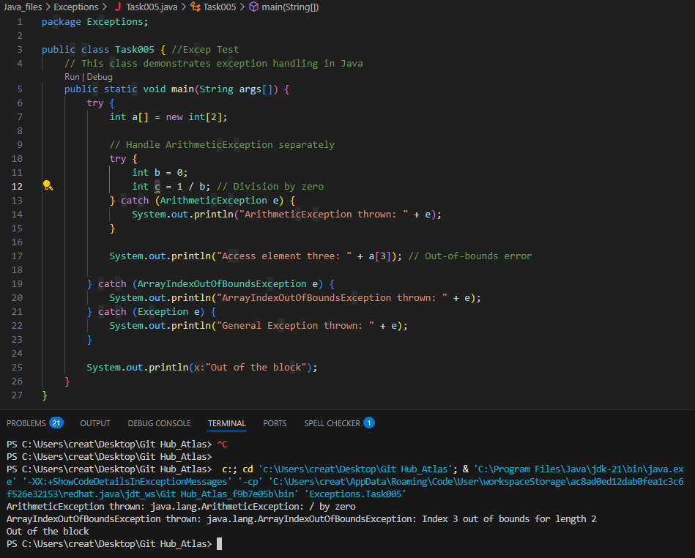

Task 6:

What is the output of the below code… give your reason for the output

public class ExcepTest {

public static void main(String args[]) {
try {
int a[] = new int[2];
int b = 0;
int c = 1/b;
System.out.println("Access element three :" + a[3]);
}
catch (ArithmeticException e) {
System.out.println("ArithmeticException thrown :" + e);
}
catch (ArrayIndexOutOfBoundsException e) {
System.out.println("ArrayIndexOutOfBoundsException thrown :" + e);
}catch (Exception e) {
System.out.println("Exception thrown :" + e);
}
System.out.println("Out of the block");
}
}

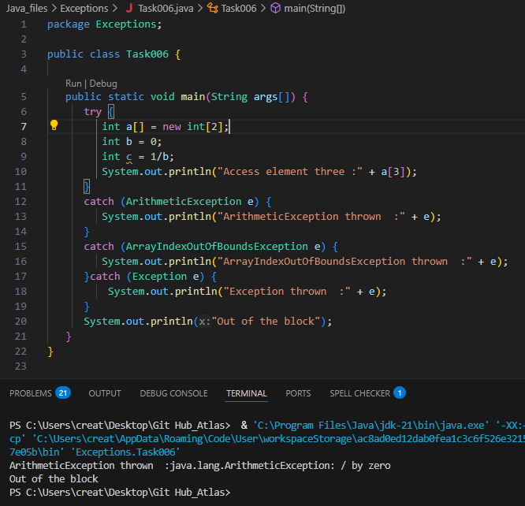

Task 7:

In the below code we are having use multiple catch in a single statement: find the output and try to understand the code..

public class ExcepTest {

public static void main(String args[]) {
try {
int a[] = new int[2];
int b = 0;
int c = 1/b;
System.out.println("Access element three :" + a[3]);
}
catch (ArrayIndexOutOfBoundsException | ArithmeticException e) {
System.out.println("Exception thrown :" + e);
}
System.out.println("Out of the block");
}
}

11.15 to 11.18

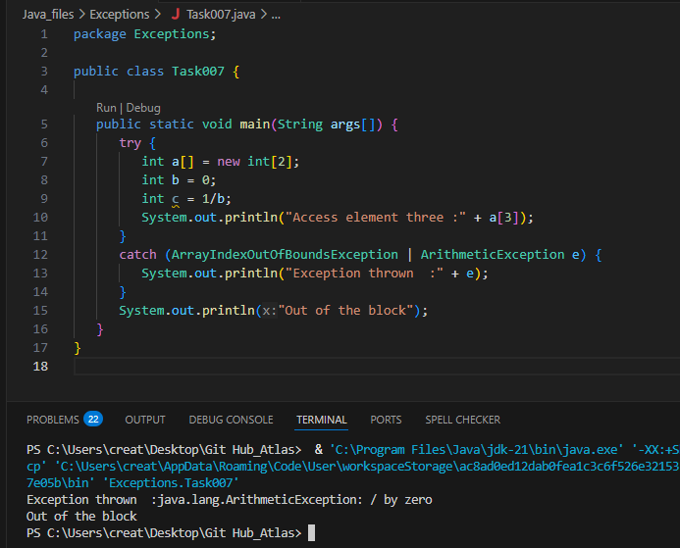
Naested try blocks

Task 008:

public class ExcepTest {

public static void main(String args[]) {
try {
int a[] = new int[2];
try {
int b = 0;
int c = 1/b;
}catch(Exception e) {
System.out.println("Exception thrown: " + e);
}
System.out.println("Access element three :" + a[3]);
}
catch (ArrayIndexOutOfBoundsException e) {
System.out.println("Exception thrown: " + e);
}
System.out.println("Out of the block");
}
}

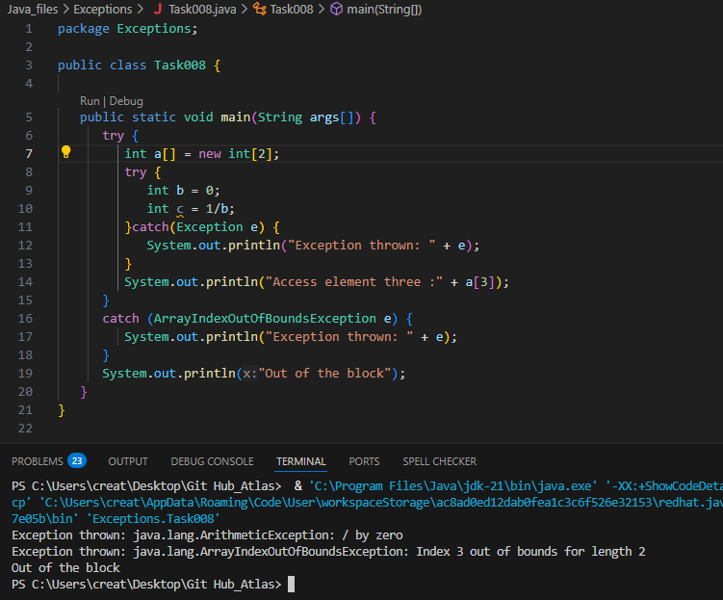

Throw and Throws:

Task 009

// Demonstrating how to throw an exception
class MyClass {

static void fun() throws IllegalAccessException
{
System.out.println("Inside fun(). ");
throw new IllegalAccessException("demo");
}

public static void main(String args[])
{
try {
fun();
method2(); → arrayindex…
Method3() —> file not found….
}
catch (IllegalAccessException e) {
System.out.println("Caught in main.");
}
}
}

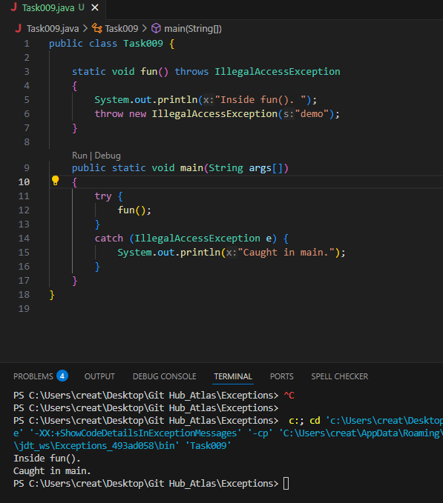

Task010:

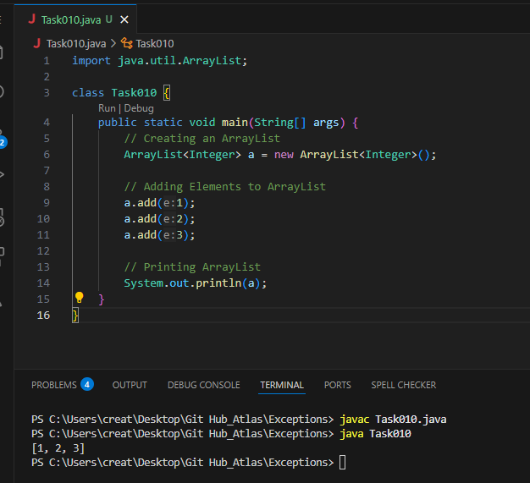
Task011
Wap to create an array list to display 10 elements using a for loop.
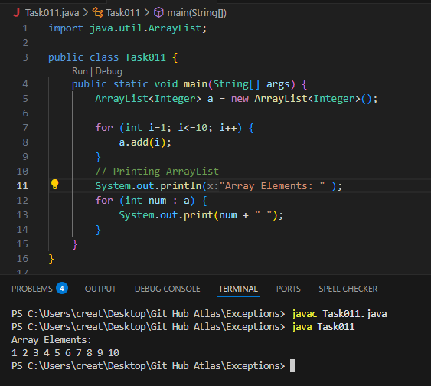
Task 012:
Find the output of the be code snippet..
// Addition, Deletion and Updation of Element
import java.util.*;
class Main {
public static void main(String args[]){
ArrayList<String> al = new ArrayList<>();
al.add("Prasunamba");
al.add("Meher");
System.out.println("Orignal List : "+al);
al.add(1, "Hello");
System.out.println("After Adding element at index 1 : "+ al);
al.remove(0);
System.out.println("Element removed from index 0 : "+ al);
al.remove("Prasunamba");
System.out.println("Element Prasunamba removed : "+ al);
al.set(0, "K");
System.out.println("List after updation of value : "+al);
}
}
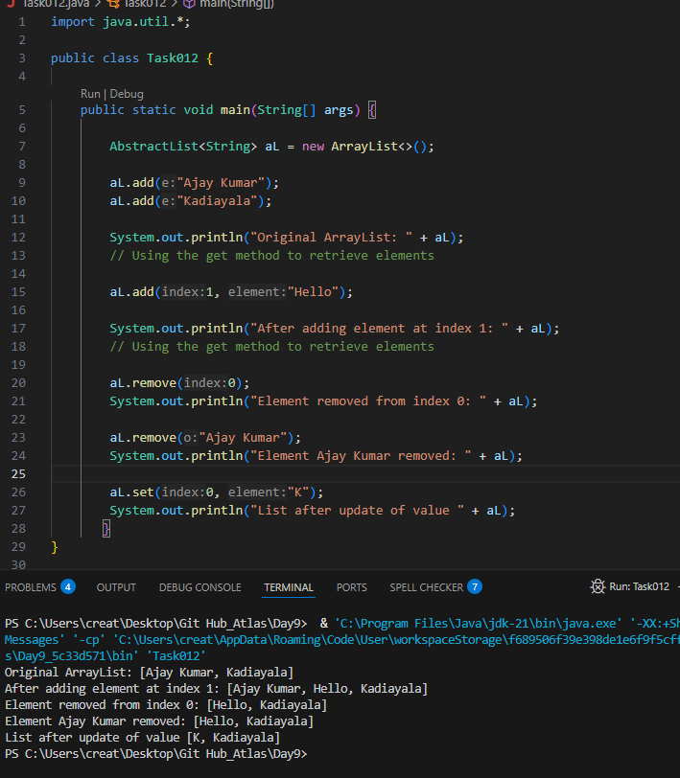
Tasks 013:
User defined Exception:
// A Class that represents user-defined exception
class Customer extends Exception {// predefined class Exception
public Customer(String m) { // constructor with parameters
super(m); // parent class constructor
}
}
// A Class that uses the above MyException
public class setText {
public static void main(String args[]) {
try {
// Throw an object of user-defined exception
throw new MyException("This is a custom exception");
}
catch (MyException ex) {
System.out.println("Caught");
System.out.println(ex.getMessage());
}
}
}
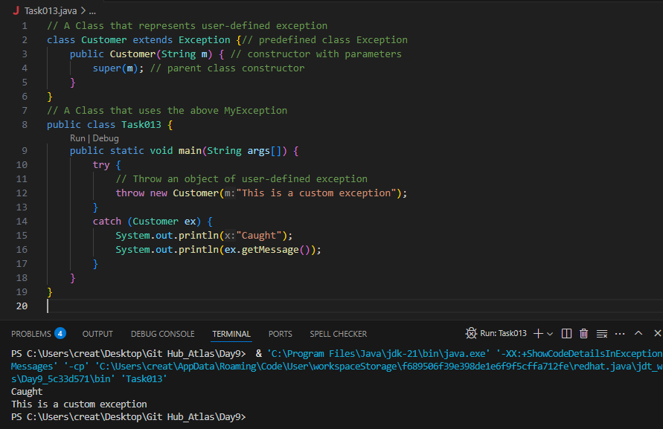
Task014
Task 014
Inheritance
Classes customer/ person , employee, Manager … 2 variables in each class
Driver class – display all the variables… toString();
Hint : use getter and setters..

Inner classes
Task 015
What is the output of the below code snippet.. Explain ..
class OuterClass {
int x = 10;
class InnerClass {
int y = 5;
}
}
public class Main {
public static void main(String[] args) {
OuterClass myOuter = new OuterClass();
OuterClass.InnerClass myInner = myOuter.new InnerClass();
System.out.println(myInner.y + myOuter.x);
}
}
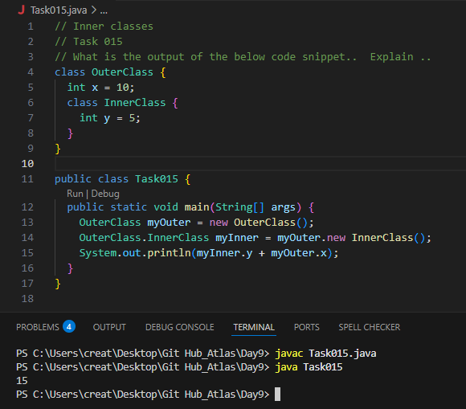

Task 016
Use the above code and make the inner class as private and see the output..
Ex: private class InnerClass {

